43.44:
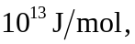 which is far higher than typical heats of combustion.

